Autonomous Snow Clearing Robot for Kingston City Sidewalks
Brief Description: This project will design the hardware and software architecture for a robot that autonomously clears snow from sidewalks around Queen’s University and downtown Kingston. The project should culminate in an early prototype demonstrating design feasibility.
Requisite Skills and Background: Hardware and mechanical design, algorithms, controls, and careful definition of specifications and requirements. The team should have diverse complementary expertise so subsystems can be developed and integrated effectively.
Budget and Resources: The $500 budget will support a life-sized prototype with simplified snow-clearing capability or more capable prototypes of specific subsystems.
Client: City of Kingston?
Problem Statement: The sidewalks in Kingston are often left with snow for extended periods of time due to labour and equipment shortages.
Main Features:
- Clear snow
- Street map pre-loaded
- Pre-defined route
- Sensors for snow/ice identification and immediate reactivity
- Human detection & E-stop
- Lights and audible alarms
Things to Consider:
- Inclement weather will affect vision
- Remote communication and tracking
- How snow is being cleared (plow vs blower vs other)
- Environmental conditions for deployment (how much is too much? Visibility?)
- What happens if robot tips over? Incident detection? Alert remote operator?
- Testing outside of winter months (use the memorial center arena)

Hardware/ Software Requirements:
- LiDAR/Camera vision
- GPS/localization
- Accelerometer/Gyro
- ROS2
- Safety systems
- Onboard computing
- Xbox controller drivable for testing purposes
Reference Ideas:
- Food delivery robot
- Current sidewalk snowplow models
Goal For End of Capstone:
- Follow a route of ____ m of street including cross walk, with people around. Snow of ___ depth
Plans For Exhibition:
- Video with real snow
- Poster
Notes from Meeting with Gammell:
- Expect a base from him, or pivot to using a handcart
- Sub divide project into individual pieces that come together
Discussion with Josh 09-24-2026
- Interesting suggestion from bro: Narrow our scope to maybe one specific spot on campus (e.g. the walkway between ARC/Mitchell/Kin Building/JDUC) that the robot will specifically target
- Maybe the key here is to target more "low hanging fruit" with automation – what can we easily automate that will allow snow removing personnel to give their attention to more serious or urgent tasks
- Shift focus to: On campus, specific high traffic targeted area
- In terms of "sensing snow" limit scope to robot can only be deployed when there is only between 1 and 5 inches of snow (for example)
- We need to delegate roles:
  - Plow/mechanical
  - Electrical
  - Software – Route planning/fencing, computer vision, route following
- We should make a Github

September 27, 2026 (in MREN room)

Project definition
Primary stakeholder:
Queen’s Physical Plant Services
City of Kingston (current snow removal employees, management)
Queen’s University Students
Kingston citizens (walkers, drivers)
Ingenuity Labs (borrowing robot/parts)
Visually/hearing/mobility impaired
Queen’s Physical Plant Services
Target location:
Targeted location on campus, high traffic, multiple times per day. Shovel-able snow. No ice.
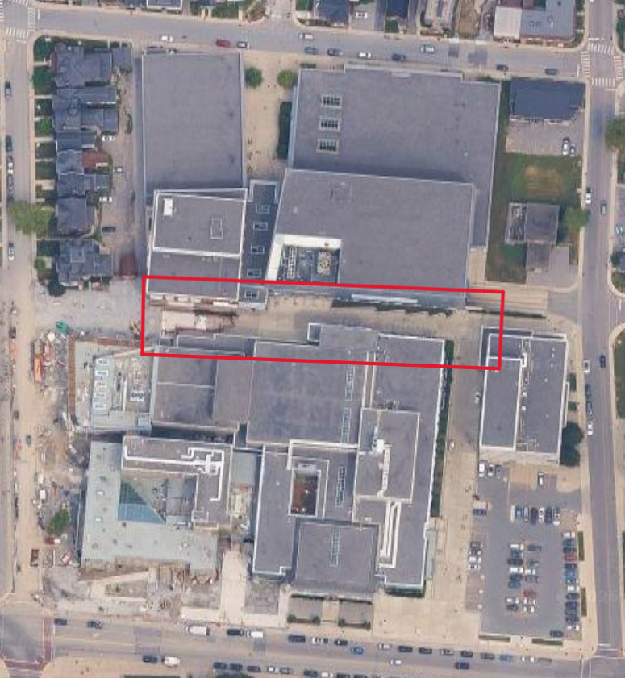
Walkway between ARC/Mitchell/Kin Building/JDUC NOT during 10 minute cross over period.
Pathway between ARC/JDUC/Mitchell/Kin Building
Primary use case:
Repeated autonomous clearing of light snowfall from a known pedestrian route so staff can focus on higher-priority removal
Maximum snow depth:
6in but TBD based on testing?
Snow type:
Shovel-able + slush. Fresh/light-to-moderate snow. Exclude deep packed snow, heavy ice, and freezing rain.
Clearing mechanism:
Angled front plow

Clearing width:
Hockey wheel bases is 27.5” so approximately 30”
Route length target:
5m free drive, 5m against a wall, and one turn without user interventions
Plan routes to be 50m with many turns and attempt to do that on single charge or gas tank
Maximum robot speed:
Slow (expecting 1m/s but will test later)
Autonomy approach:
Teach/repeat / waypoints / path planning
- LiDAR/Camera vision
- GPS/localization
- Accelerometer/Gyro
- ROS2
Localization:
- GPS/GNSS
- Wheel encoders
- IMU
Obstacle sensing:
- People
- Static objects
Pedestrian handling:
People & obstacle detection with E-stop. Slow or stop, then wait for the path to clear.
Road crossings:
Excluded from this, route should avoid public road crossings
Remote supervision:
Operator can view robot status/location and receive fault alerts
Emergency-stop strategy:
Physical E-stop on robot and remote software stop, motion disabled on critical fault or loss of communication
Manual control:
Xbox / other
Target runtime:
5 minutes (see minimum route following)
Final demonstration:
What would make us say "the project worked?"
Navigation test: Robot follows a defined route within +/ X cm lateral error
Snow-clearing test: Robot removes at least X% of snow from a defined-width path
Human-safety test: Robot detects a pedestrian within X m and stops at least Y m away

Requirements:
Must have | Should have | Stretch
Drives | Route adaptation for unknown obstacles | Snow blower  Multiple routes  Ice detection
Snow removal mechanism |  | Automated path creation
Path following | Human/obstacle detection  Static obstacle, go around algorithm | Salt dispensing  Smart snow removal and sensing  Lifting snow
Human/obstacle detection  Static obstacle, stop and wait for obstacle to move before proceeding | Route progress UI | Human/obstacle  detection, dynamic obstacle detection and avoidance, "smart" obstacle avoidance
Computer Vision  Battery monitoring | Tip detection  If roll/pitch exceeds threshold, stop motors and send warning to operator
Manual driving mode
E-stop
Localization/Geofence
State based notifications in terminal etc
- Waiting
- In progress
- Upset
- Finished

Out of Scope
- Home base for charging
- Fleet management

Meeting with Phillip from Queens PPS
- Introduction’s
- Talked about Husky vs Kubota
- Overview of Queen’s Snow Removal
  - Grounds team handles sidewalks/pathways
  - City sidewalks within boundary are done by the Queen’s team
  - Roadways and parking lots are contracted out
  - Doorways and stairways are done by the contractor
  - Event is defined as any time there is any accumulated snow fall
  - Also considered when there is flash freeze due to melting and freezing
  - Snowbanks are put downhill from the generic flow of traffic
  - Picnic tables/bike racks and other objects are labour intensive to clear from snow.
  - Deicing is critical, granular, or liquid(beet juice) solutions as removing snow can create more hazards then benefit.
- Timelines
  - Campus open and safe by 7am
  - Contractors withing 2 hours of event starting.
- Pinch Points
  - Related to timing of when the event happens and relevant to student timing
- What is required to be safe
  - No specific safety metrics
  - Minimum access is bare and wet
- Liabilities
  - Tons of legal aspects related to slipping and falling due to poor conditions
  - Cost for insurance of contractors
- Location
  - East side of Botterell Hall, pending approval from Facilities
  - Tennis courts could work as well

